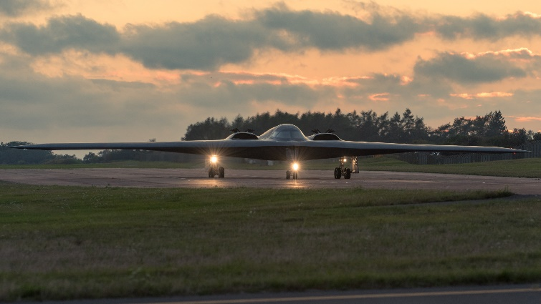**Lt. Col. (ret.) Jennifer Jeffords, No. 3, Spirit Number 326**

**By Brye Steeves**

**509th Bomb Wing Public Affairs**

The first pilot Jennifer Jeffords ever knew was her dad.

He had his private pilot’s license and she often flew as a passenger in a Cessna. As a child, Jeffords watched him in awe as he maneuvered the skies “like a bird up there, gliding.”

“The idea of exploring and being part of the world above the ground – I knew I would go make that happen.”

Years later, their roles would reverse.

Jeffords – determined since elementary school – first piloted a glider plane at the U.S. Air Force Academy in Colorado Springs. Not long after, she and her dad were back in the cockpit together. This time, Jeffords was the pilot and he was the passenger.

“He was so proud,” Jeffords says of her dad, who has since died. “Both my parents were so supportive, always encouraging.”

Her childhood dream was materializing after years of unwavering determination and “keeping my nose to the grindstone.” Jeffords faced obstacles, including a year-long delay to enter the academy due to a knee-replacement surgery, but always remained focused on becoming a pilot.

After she graduated from the Air Force Academy in 1998 and then pilot training in Texas a short time later, Jeffords first flew the Airborne Warning and Control System, more commonly called the AWACS, while stationed in Oklahoma.

In search of an Air Force mission that would allow her “to be up front in the fight,” Jeffords applied to the B-2.

In May of 2004, became the third woman to fly the $2.2 billion stealth bomber. Jeffords felt pressure, but because of the gravity of the task, not her gender.

“You’re not actually a female B-2 pilot, just a B-2 pilot. I’m just a pilot,” Jeffords says simply. Just like her dad.